|  |  |  |  |  |  |  |  |  |  |  |  |  |  |  |
| --- | --- | --- | --- | --- | --- | --- | --- | --- | --- | --- | --- | --- | --- | --- |
| Final Project  Ger’s Garage  Balazs Barcza  Student Number : SB18002 |  | |  |  | | --- | --- | | *Date :* | 15/06/2019 | |  |  | |  |  | |  |  | |  |  | |  |  | |

# 0 INDEX

Table of Contents

0 INDEX 2

1 Project Introduction: 4

1.1 Part 1: Overview 5

1.2 Part 2: Purpose 5

2 Literature Review: 6

2.1 Part 1: cloud computing services 6

2.2 Part 2: Google Cloud Platform 6

2.3 Part 3: GCP SQL Database 6

3 System Analysis and Design: 7

3.1 Part 1: Functional Requirements 7

3.2 Part 2: User Interface Design 7

3.3 Part 3: Functional & Data Design 8

4 Implementation of the system: 9

4.1 Part 1: Software Architecture Implementation 9

4.2 Part 2: System Analysis and Design Reflections 9

4.3 Part 3: Problems confronted 9

5 Testing and Evaluation: 11

5.1 Part 1: Functional Requirements 11

5.2 Part 2: Instructions for user 11

5.3 Part 3: Commercialisation / marketing 12

6 Conclusions: 13

6.1 Part 1: evaluate the success and results of the project 13

6.2 Part 2: Suggestions for further work 13

7 Code Listings: 14

7.1 Part 1: ##### 14

7.2 Part 2: ##### 14

7.3 Part 3: ##### 14

8 Appendix B: (other technical or data appendices as required): 15

8.1 Part 1: Project Planning  15

8.2 Part 2: Reflective Learning Journal  15

9 List of References: 16

# Project Introduction:

*The first chapter sets the background and motivation for the project. The problem to be*

*solved is stated, with the project aims and a list of specific objectives.*

*The chapter could include:*

*- A brief synopsis of the project context (supplied by CCT)*

*- General areas of computing that project context covers / requires knowledge of*

*- Brief summary of your initial proposed plan for addressing the project context*

*- Short section arguing ‘why’ this is a good project – outline Individual’s skills, interests,*

*strengths – they Individual can describe how the project brings together many of the*

*modules they’ve listed*

*- Novel aspects – a real world business or organisation or taking advantage of new*

*technology*

## Part 1: O**verview**

Ger is a mechanic who runs a small garage. He carries out maintenance checks for all kinds of small to medium vehicles (i.e. motorbikes, cars, small vans and small buses). He has a small number of staff who work with him.

In most cases, a maintenance check will require parts or other supplies (e.g. brake fluid; engine oil). He keeps a stock of common supplies at his garage and sells them to customers if/when needed. He needs an online service to allow customers to book their vehicles in for a check-up or service. He has asked you to build a WEB-BASED [OR MOBILE] application to fulfil his requirements.

**Project overview:**

He carries out maintenance checks for all kinds of small to medium vehicles (i.e. motorbikes, cars, small vans and small buses). He has a small number of staff who work with him.

In most cases, a maintenance check will require parts or other supplies (e.g. brake fluid; engine oil). He keeps a stock of common supplies at his garage and sells them to customers if/when needed.

He needs an online service to allow customers to book their vehicles in for a check-up or service. He has asked you to build a WEB-BASED [OR MOBILE] application to fulfil his requirements.

**Ger’s garage minimum requirements:**

* A new website for Ger’s Garage is created that advertises his garage and his services. [OPTION – YOU COULD CREATE THIS AS A MOBILE APPLICATION INSTEAD]

1. websites
2. moblie applications

**Booking services:**

Customers can register on the website and book their vehicle in for a service OR a repair.

There must be AT LEAST 4 types of booking:

1. Annual Service
2. Major Service
3. Repair / Fault
4. Major Repair

**Login Service:**

Registered customers should be able to login on future occasions and the system should remember their details. This would include details of the vehicle they LAST booked in to the garage

**Booking checklist:**

Customers need to be able to select a DATE for their service. The website should limit the number of bookings allowed per day (you can decide the limit, but this should be realistic for a small garage). If there is no available space for a day, then the customer should not be able to book a service on that day.

Ger’s garage is closed on Sundays for service bookings. DO not allow customers to select a Sunday.

**Information about the vehicles:**

Customers will need to be able to provide some basic information about themselves and their vehicles:

* Customer name & contact details (mob phone essential)
* Vehicle type & make
* Vehicle licence details
* Vehicle engine type
  + diesel
  + petrol
  + hybrid
  + electric
* Booking Required
  + Annual Service
  + Major Service
  + Repair / Fault
  + Major Repair
* Customer Comments (to allow customer add any notes they want to add, such as a description of the problem)

**Ger administration:**

Ger needs to have an admin access to the site to view bookings for any particular day OR week, so that he can plan his work & staff rostering. You can assume Ger has at least 4 mechanics available on any one particular day (you can change this, but be realistic – this is a small garage!)

He needs to be able to allocate a mechanic to each vehicle. You can assume that all of his staff are able to carry out any type of service / repair and that each mechanic could carry out AT MOST 4 services/repairs in one day. If the booking is a Major Repair then this would count double.

**Printing services:**

He needs to be able to print the schedule for any particular date.

He needs to be able to allocate costs to each booking. You can assume a basic fixed cost (e.g. an Annual Service might cost €200 minimum).

**Items/Parts:**

Ger needs to be able to add to this the cost of any item/parts that were needed to fix/service the vehicle. For example, if a tyre needed to be replaced then the cost of the tyre would be added and the cost of carrying out a “wheel balancing” would be added.

You can decide the cost of each item/part and what types of items/parts you include, but you should be realistic. You do not have to provide an exhaustive list of parts, but the more you provide the more realistic your final product will be. AT A MINIMUM you should provide 40 different parts/items for the garage.

Note that the customer has to provide details of the type and make of car (e.g. Car - Ford Feista). The site MUST allow for motorbikes, cars, small vans and small buses. You can decide how many different makes to provide as default, but you MUST provide at least 30 in total. Make sure to allow the user choose “other” if their vehicle is not in the list.

**Booking statuses:**

Ger needs to be able to set each booking to one of 5 possible statuses:

1. Booked – this is the default status when a booking is made
2. In Service – when the vehicle arrives at the garage
3. Fixed / Completed – when the vehicle is ready for collection
4. Collected – When the customer has taken the vehicle away and paid their bill
5. Unrepairable / Scrapped – when the fault cannot be fixed; in this case the car has either been taken away by the customer or has been sent for scrap.

**Invoice:**

Ger needs to be able to print an “invoice” or bill for each customer when the service/repair is complete. This should provide an itemised bill for the customer. For example:

CUSTOMER:

Joe Bloke

Mob No: 085 02140201

Vehicle: Peugeot 406

Licence: 12 G 123456

Annual Service €189

Mini Valet €39

Car mat €17

TOTAL DUE €245

Payment due on collection.

You can assume that the actual payment is handled by Ger at his checkout / on another system. You do not need to process payments or issue a receipt. To achieve a distinction grade you should aim to include additional functionality that has not been specified here but which would make sense within the project brief.

**REPORT GUIDANCE:**

For the design section of your report, you should aim to include the following

ESSENTIAL:

* Wireframe designs for the website. Include key pages – you may not need to include every single page.
* Functional Requirements – set out the various requirements in a structured manner and specify a level of priority (e.g. Must have, etc.)
* Data Requirements – set out the data you will need to store using a ‘data dictionary’ or similar structured layout. Make sure you specify data types, restrictions and any other important details
* Database tables – should be normalized to 3NF minimum

DIAGRAMS

* Include design diagrams to detail your design. Examples would include: a class diagram, and E-R Diagram, Use-cases.

JUSTIFICATION

*Why did you choose this wireframe design? How did you determine your data requirements? How did you construct your class diagram and/or use-cases?*

## Part 2: Purpose

***Why need Gerg a website?***

Small medium or large size of the business has to have a website or mobile app because this is the key to making sales and contact with the customers. Consumer behavior changes over time to adapt to modern technology, and consumer behavior has changed to adapt to the digital age.  
 At the 21 century, the key is to get real-time and communication with the customer. The 1930s, advertising in the Yellow Pages. It was a standard operating procedure for most businesses.   
Then came the world wide web ( WWW) and a new disruption to the commercial status of the digital transformation. As more and more consumers realized they could find what they needed online faster and more effectively than a phone book, behavior moved away from using the printed directory. Nowadays at 2019, and the number of purchasers that go online to find a local business has jumped to 97 percent. If you want them to choose your company, you need to be found online—meaning you need a website.

“Websites work. No matter what your business or profession, a website can generate business, promote goodwill among customers and prospects, and deliver strong marketing messages - whether your business is small, large or in-between, well-established or brand-new.

People use the Web in greater and greater numbers, more and more every day. Even if you are a completely local small business, service, contractor or consultant, odds are people have used search engines to look for your web site - and if you don't have a web site... well, you get the picture.

” <http://www.networksolutions.com/education/business-needs-website/>

The is a couple of the reason why small business needs a Website

* The customers expect it.  
   The customer has to trust a business
* It provides social proof.  
   The potential customers are already looking for you online, including customer recommendations on your site is a great way to impress potential clients.
* Influence the clients

You can control the communication channel

* You can control the communication channel
* The competitors all have company websites.
* You will be visible on the Google search results
* Display your products or outline your services in detail

***Web Developer:***

A Web developer is a programmer whose development of applications to the World Wide Web ( WWW ). Web developers design website and website application. Web developers are responsible for designing and develop a website and website application. The developer can use many languages (HTML, PHP, JavaScript, JQuery, etc), and can develop with different technology. He or she has to manage the site, implement application features and manage security.

[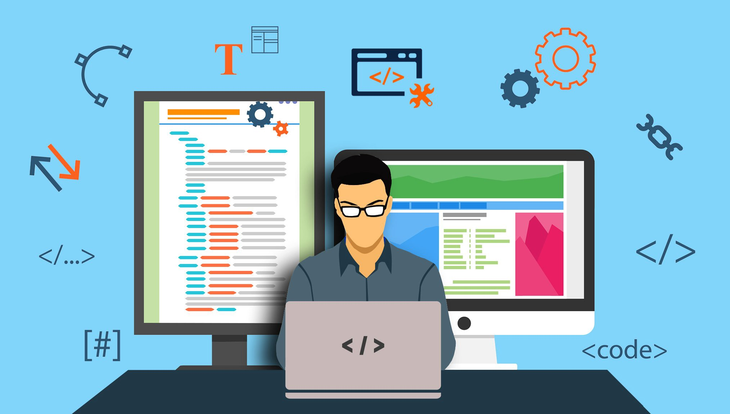https://medium.com/level-up-web/developer-roadmaps-all-in-one-place-75c0402db0e0](https://medium.com/level-up-web/developer-roadmaps-all-in-one-place-75c0402db0e0)

The 9 Web Technologies Every Web Developer Must Know in 2019

1. Browsers  
2. HTML & CSS  
3. Web Development Frameworks  
4. Programming Languages  
5. Protocols  
6. API  
7. Data formats  
8. Client (or Client-side)  
9. Server (or Server-side)

More information <https://tms-outsource.com/blog/posts/web-technologies/>

***My origin project plan.***

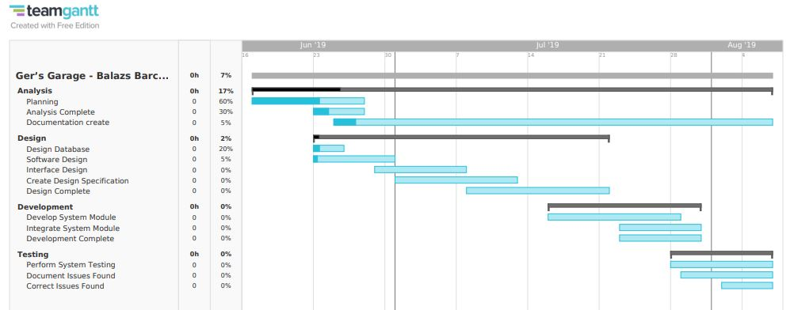

I have chosen this project because I wanted to build an app (website) and I wanted to use the Google cloud platform. I think this is the future more and more project will move to the cloud. It is a game changer because It is more playable and advances.  
1. Less Costs  
The services are free from capital expenditure. There are no huge costs of hardware in cloud computing. You just have to pay as you operate it and enjoy the model based on your subscription plan.  
  
2. 24 X 7 Availability  
Most of the cloud providers are truly reliable in offering their services, with most of them maintaining an uptime of 99.9%. The workers can get onto the applications needed basically from anywhere. Some of the applications even function off-line.  
  
3. Flexibility in Capacity  
It offers flexible facility which could be turned off, up or down as per the circumstances of the user. For instance, a promotion of sales is very popular, capacity can be immediately and quickly added to it for the avoidance of losing sales and crashing servers. When those sales are done, the capacity can also be shrunk for the reduction of costs.  
  
4. All over Functioning  
Cloud computing offers yet another advantage of working from anywhere across the globe, as long as you have an internet connection. Even while using the critical cloud services that offer mobile apps, there is no limitation of the device used.  
  
5. Automated Updates on Software  
In cloud computing, the server suppliers regularly update your software including the updates on security, so that you do not need to agonize on wasting your crucial time on maintaining the system. You find extra time to focus on the important things like ‘How to grow your businesses.  
  
6. Security  
Cloud computing offers great security when any sensitive data has been lost. As the data is stored in the system, it can be easily accessed even if something happens to your computer. You can even remotely wipe out data from the lost machines for avoiding it getting in the wrong hands.  
  
7. Carbon Footprint  
Cloud computing is helping out organizations to reduce their carbon footprint. Organizations utilize only the amount of resources they need, which helps them to avoid any over-provisioning. Hence, no waste of resources and thus energy.  
  
8. Enhanced Collaboration  
Cloud applications enhance collaboration by authorizing diverse groups of people virtually meet and exchange information with the help of shared storage. Such capability helps in improving the customer service and product development and also reducing the marketing time.  
  
9. Control on the Documents  
Before cloud came into being, workers needed to send files in and out as the email attachments for being worked on by a single user at one time ultimately ending up with a mess of contrary titles, formats, and file content. Moving to cloud computing has facilitated central file storage.  
  
10. Easily Manageable  
Cloud computing offers simplified and enhanced IT maintenance and management capacities by agreements backed by SLA, central resource administration and managed infrastructure. You get to enjoy a basic user interface without any requirement for installation. Plus you are assured guaranteed and timely management, maintenance, and delivery of the IT services.

<https://www.idexcel.com/blog/top-10-advantages-of-cloud-computing/>

# Literature Review:

*The aim of this chapter is to present all academic research carried out throughout the*

*project cycle. It is important that learners produce research that defends their*

*justifications for choosing one from of technology or software over another, and other*

*sources of information that have helped inform the individuals thinking, planning and*

*delivery of the project.*

## Part 1: Cloud Computing Services

What is the cloud computing?

Before we go deeper to cloud computing We have to define the cloud. This is the technology not older than 10 years and nowadays is happening the change. Why the people using the cloud that a logo, Because It is easy to draw it. But If we looking at the big picture we will see cloud computing is similar that the real cloud. In the cloud, We can find a lot of h2o and cloud computing we will find a lot of computers is connecting each other.

[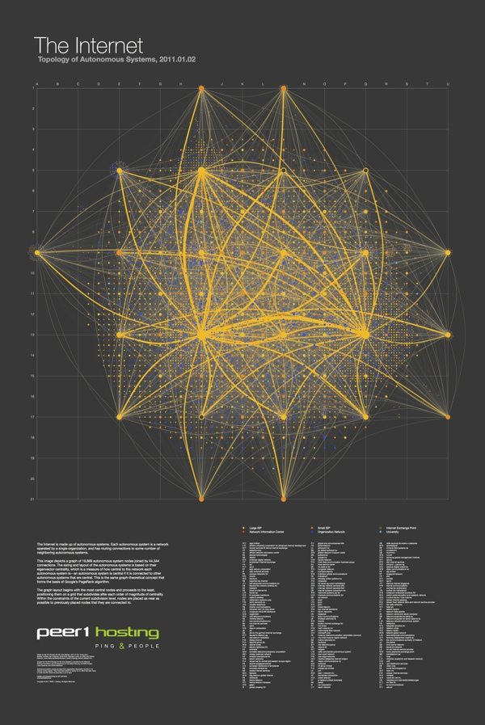The Map of the Internet — Cool Infographics](https://coolinfographics.com/blog/2011/4/7/the-map-of-the-internet.html)

<https://coolinfographics.com/blog/2011/4/7/the-map-of-the-internet.html>

“It’s a layout of all the networks that are interconnected to form the internet. Some are run by small and large ISPs, university networks, and customer networks - such as Facebook and Google. It’s visual representation of all those networks interconnecting with one another, forming the internet as we know it. Based on the size of the nodes and the thickness of the lines, it speaks to the size of those particular providers and the connections.”

**Randy Krum** Designer | Author | Instructor

[**https://coolinfographics.com/blog/2011/4/7/the-map-of-the-internet.html**](https://coolinfographics.com/blog/2011/4/7/the-map-of-the-internet.html)

Those small computers are working together that a big resource. Those computers are sharing the resource with each other.  
  
Cloud computing is the on-demand availability of computer system resources, especially data storage and computing power, without direct active management by the user. The term is regularly used to describe datacenters available to many clients over the Internet. Big clouds, dominant today, often have roles spread over many locations from central servers. If the connection to the user is relatively close, it may be designated an edge server.

Fundamentally, cloud computing is the delivery of computing services including servers, storage, databases, networking, software, analytics, and intelligence over the Internet (“the cloud”) to offer faster innovation, flexible resources, and economies of scale. You typically pay only for cloud services you use, helping you lower your operating costs, run your infrastructure more efficiently, and scale as your business needs change.

**Cloud computing services have several standard properties:**

* Virtualization- cloud computing utilizes server and storage virtualization extensively to allocate/reallocate resources rapidly
* Multi-tenancy-resources are pooled and shared among multiple users to gain economies of scale
* Network-access- resources are accessed via web-browser or thin client using a variety of networked devices (computer, tablet, smartphone)
* On demand- resources are self-provisioned from an online catalogue of pre-defined configurations
* *Elastic*-resources can scale up or down, automatically
* Metering/chargeback-resource usage is tracked and billed based on service arrangement

**Cloud computing services delivered internally or by third-party service:**

* Software as a Service (SaaS) – software runs on computers owned and managed by the SaaS provider, versus installed and managed on user computers. The software is accessed over the public Internet and generally offered on a monthly or yearly subscription.
* Infrastructure as a Service (IaaS)– compute, storage, networking, and other elements (security, tools) are provided by the IaaS provider via public Internet, VPN, or dedicated network connection. Users own and manage operating systems, applications, and information running on the infrastructure and pay by usage.
* Platform as a Service (PaaS)– All software and hardware required to build and operate cloud-based applications are provided by the PaaS provider via public Internet, VPN, or dedicated network connection. Users pay by use of the platform and control how applications are utilized throughout their lifecycle.

**Cloud services delivery models**

[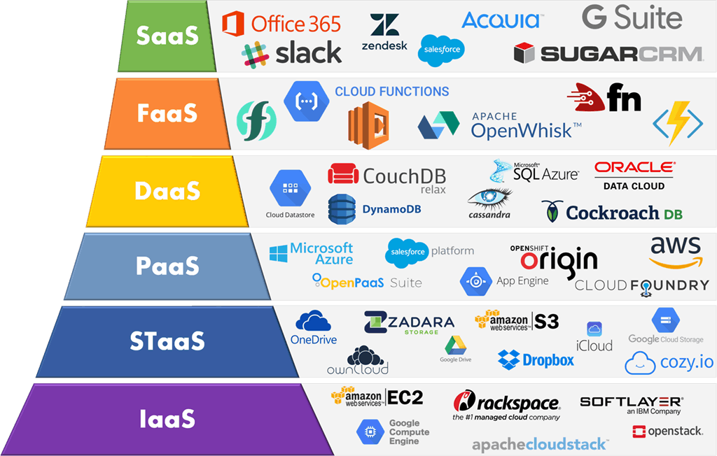https://imelgrat.me/cloud/cloud-services-models-help-business/](https://imelgrat.me/cloud/cloud-services-models-help-business/)

**Models of cloud computing:**

Not all clouds are the same, different users, different type of cloud computing system right for them. Different models, types, and services offer the right solution. There are three different ways to deploy cloud services: on a public cloud, private cloud, or hybrid cloud.

[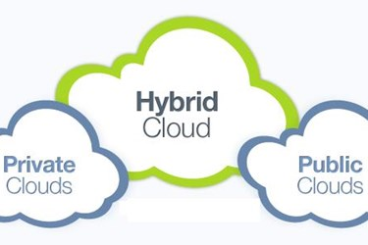**https://www.allcovered.com/the-learning-center/cloud-revolution-or-evolution-582**](https://www.allcovered.com/the-learning-center/cloud-revolution-or-evolution-582)

* Public cloud  
  Public clouds are owned and operated by a third-party cloud service providers, Public cloud provides computing resources, like servers and storage, over the Internet. The cloud provider owned and managed all hardware, software and other infrastructure.
* Private cloud  
  A private cloud belongs to cloud computing resources used exclusively by a single business or organization. It can be located on the company`s data center, or companies can pay third-party service providers to host private cloud.
* Hybrid cloud  
  Hybrid clouds join public and private clouds. The technology permits applications and data to be shared between them. The data and applications can transfer between private and public clouds, a hybrid cloud gives to the business adaptability, more deployment options, and helps optimize your current infrastructure, security, and compliance.

**Cloud computing services offer numerous benefits:**

* Faster implementation and time to value
* Anywhere access to applications and content
* Rapid scalability to meet demand
* Higher utilization of infrastructure investments
* Lower infrastructure, energy, and facility costs
* Greater IT staff productivity and across organization
* Enhanced security and protection of information assets

**Cloud computing in the business view:**

* Cost  
  If you use Cloud computing You do not need to buying hardware and software and setting up and running on-site datacenters—the racks of servers, the round-the-clock electricity for power and cooling.
* Productivity  
  Datacenters typically require a lot of “racking and stacking”—hardware setup, software patching, and other time-consuming IT management chores. Cloud computing eliminates the need for many of these jobs, so IT teams can spend time on achieving more important business goals.
* Security  
  The cloud providers offer methods, technologies, and controls and security on your products. It is helping protect your data, apps, and infrastructure.
* Performance  
  The most significant cloud computing services run on a worldwide network of secure datacenters, which are usually improved to the latest generation of fast and efficient computing hardware. This offers several benefits over an individual corporate datacenter, including reduced network latency for applications and greater economies of scale.
* Global scale  
  The cloud computing service can be scale, So the users can choose the right size of IT resources. Can make computer power stronger, storage size, change location.
* Speed  
  The system more flexibility, few minutes and the user can create service.
* Reliability  
  Cloud computing makes data backup, recovery, faster and save because data can be copied at multiple locations.

[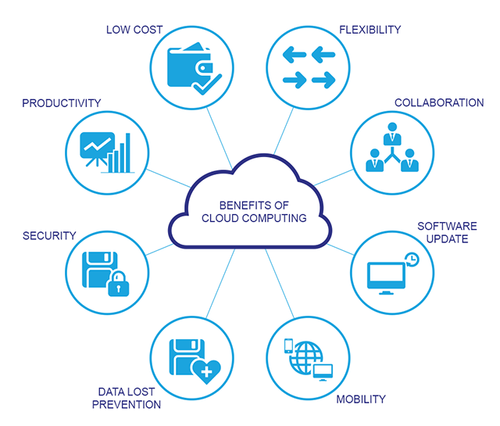http://www.visiontechme.com/cloud-computing.php](http://www.visiontechme.com/cloud-computing.php)

You can use an online service to send an email, edit documents, watch movies or TV, listen to music, play games, or store pictures and other files, it’s likely that cloud computing is making it all possible.

[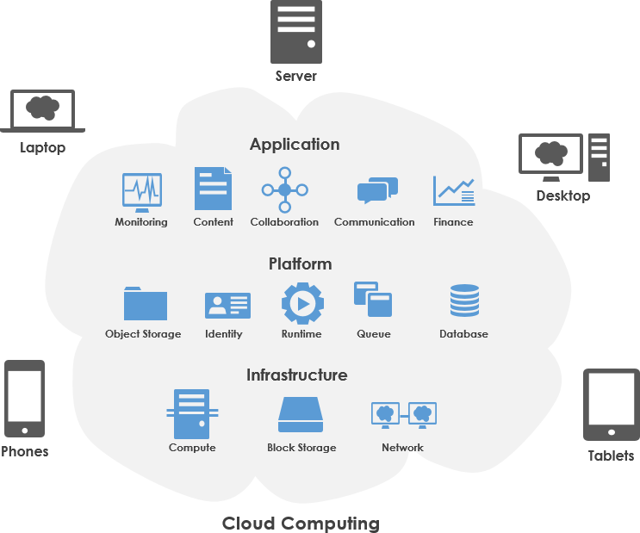*https://www.visual-paradigm.com/guide/cloud-services-architecture/what-is-aws-architecture/*](https://www.visual-paradigm.com/guide/cloud-services-architecture/what-is-aws-architecture/)

*Create new apps and services*  
Quickly build, deploy, and scale applications—web, mobile, and API—on any platform. Access the resources you need to help meet performance, security, and compliance requirements.  
  
*Test and build applications*  
Reduce application development cost and time by using cloud infrastructures that can easily be scaled up or down.  
  
*Store, back up, and recover data*  
Protect your data more cost-efficiently—and at massive scale—by transferring your data over the Internet to an offsite cloud storage system that’s accessible from any location and any device.  
  
*Analyze data*  
Unify your data across teams, divisions, and locations in the cloud. Then use cloud services, such as machine learning and artificial intelligence, to uncover insights for more informed decisions.  
  
*Stream audio and video*  
Connect with your audience anywhere, anytime, on any device with high-definition video and audio with global distribution.  
  
*Embed intelligence*  
Use intelligent models to help engage customers and provide valuable insights from the data captured.  
  
*Deliver software on demand*  
Also known as software as a service (SaaS), on-demand software lets you offer the latest software versions and updates around to customers—anytime they need, anywhere they are.

## Part 2: Google Cloud Platform

**1.Cloud Service Providers**

Cloud Computing Services are Information Technology (IT) as a service over the Internet. Cloud computing is a term which is used for storing and accessing data over the internet. It doesn't store any data on the hard disk of your PC. Cloud computing helps you to access your data from a remote server.  
  
Cloud computing services range from full applications and development platforms to servers, storage, and virtual desktops. There's are various types of cloud computing services are available in the market.

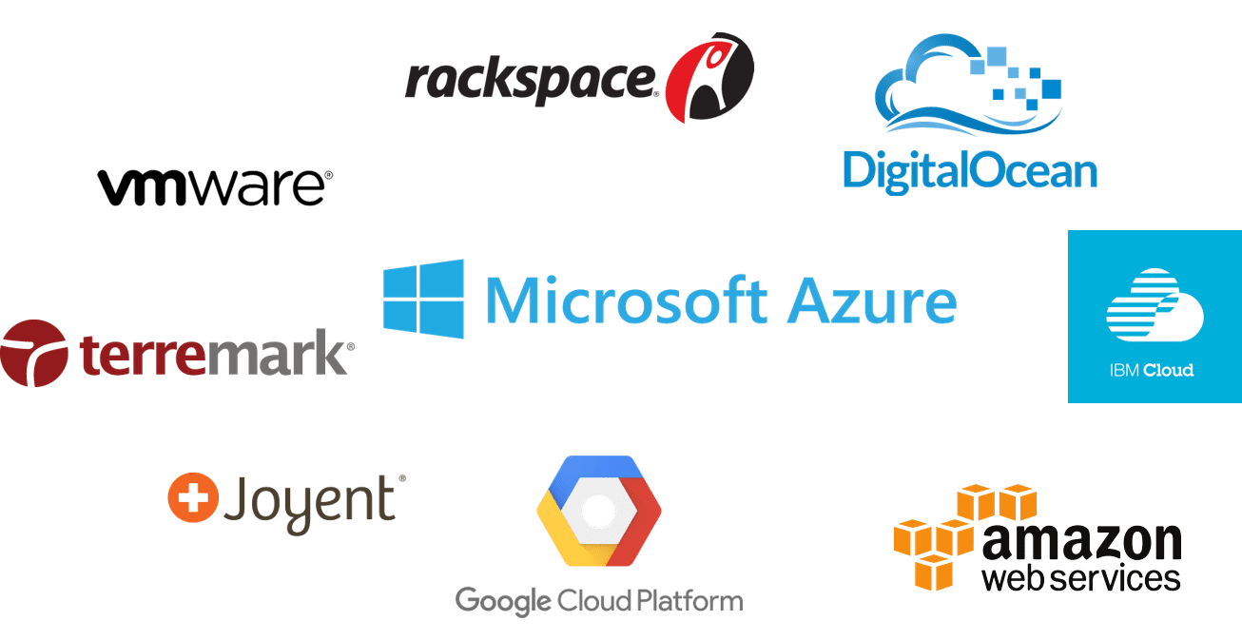

<https://www.edureka.co/blog/what-is-azure/>

Market share 2018

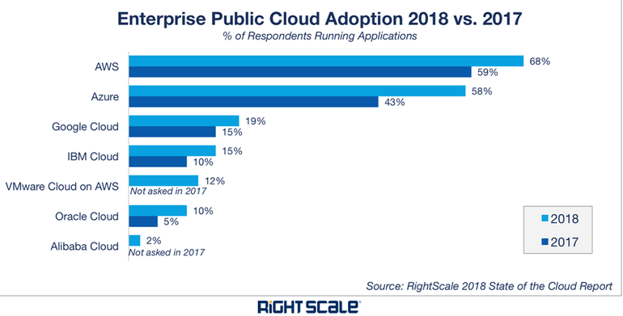

<https://www.zdnet.com/article/top-cloud-providers-2018-how-aws-microsoft-google-ibm-oracle-alibaba-stack-up/>

**2. What is the GCP and Why should We choose it.**

GCP short name of the Google Cloud Platform.

Google Cloud Platform provides infrastructure as a service, platform as a service, and serverless computing environments. Google, is a cloud computing service provider that runs on the same infrastructure that Google uses internally for its end-user products, such as Google Search and YouTube, Gsuit.

This is developing dynamically and improving and the 3rd bigger provider.  
Google offers free 300 dollars free credit, to the user. The clients can use this credit to test the system before a charge.

Google has been in the cloud computing race for much less time than the incumbent leader AWS. Amazon Web Services rakes in about $6 billion per quarter — still way ahead of Google Cloud, but from market trends, Google Cloud seems to be the fastest growing cloud platform today.

Google Cloud is differentiated and place GCP ahead of the other service providers in the industry.

* Billing per second  
   Google Cloud charges customers for usage of its compute engine instances in one-second i ncrements having a one-minute minimum.
* Big Data  
   GCP has next-gen frameworks for data warehousing, advanced machine learning, and visual analytics give it an edge in data processing and analytics.
* User-friendly interface  
   It’s CloudShell, great tutorials, clear communication, and well-integrated services.
* Kubernetes leadership  
   It is the creator of Kubernetes, the container management platform.

[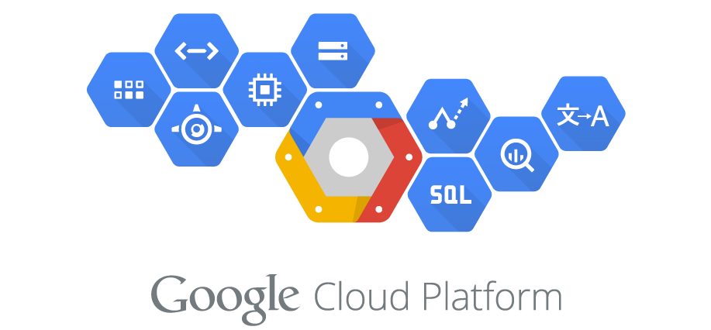https://medium.com/google-cloud/deploying-websockets-cluster-to-gcp-with-lets-encrypt-certificates-5ebb7fc1e245](https://medium.com/google-cloud/deploying-websockets-cluster-to-gcp-with-lets-encrypt-certificates-5ebb7fc1e245)

Few companies that are using Google Cloud Platform (Compute Engine or App Engine) include Spotify, HSBC, Home Depot, Snapchat, HTC, Best Buy, Philips, Coca Cola, Domino’s, Feedly, ShareThis, Sony Music, Ubisoft, and Apple.

**3. Google Cloud Platform Products**

[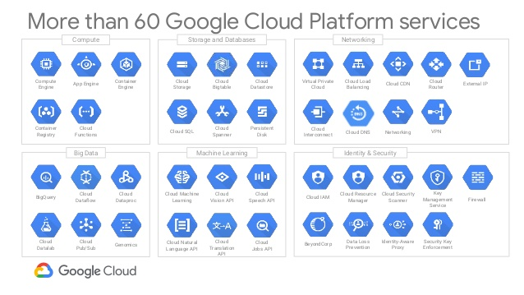https://www.slideshare.net/Hadoop_Summit/running-apache-hadoop-on-the-google-cloud-platform](https://www.slideshare.net/Hadoop_Summit/running-apache-hadoop-on-the-google-cloud-platform)

Google Cloud Platform products span the following categories:

* API management: API Analytics, API Monetization, Cloud Endpoints, Developer Portal, Cloud Healthcare API
* Artificial intelligence & machine learning: AI Hub (beta), Cloud AutoML (beta), Cloud TPU, Cloud Machine Learning Engine, Diagflow Enterprise Edition, Cloud Natural Language, Cloud Speech-to-Text, Cloud Text-to-Speech, Cloud Translation, Cloud Vision, Cloud Video Intelligence, Cloud Inference API (alpha), and more
* Compute: Compute Engine, Shielded VMs, Container security, App Engine, Cloud Functions, GPU, and more
* Data analytics: BigQuery, Cloud Dataflow, Cloud Dataproc, Cloud Datalab, Cloud Dataprep, Cloud Composer, and more
* Databases: Cloud SQL, Cloud Bigtable, Cloud Spanner, Cloud Datastore, Cloud Memorystore
* Developer tools: Cloud SDK, Container Registry, Cloud Build, Cloud Source Repositories, Cloud Tasks, and more, as well as Cloud Tools for IntelliJ, PowerShell, Visual Studio, and Eclipse
* Internet of Things (IoT): Cloud IoT Core, Edge TPU (beta)  
  Hybrid and multi-cloud: Google Kubernetes Engine, GKE On-Prem, Istio on GKE (beta), Anthos Config Management, Serverless, Stackdriver, and more
* Management Tools: Stackdriver, Monitoring, Trace, Logging, Debugger, Cloud Console, and more
* Media: Anvato, Zync Render
* Migration: Cloud Data Transfer, Transfer Appliance, BigQuery Data Transfer Service, Velostrata, VM Migration, and more
* Networking: Virtual Private Cloud (VPC), Cloud Load Balancing, Cloud Armor, Cloud CDN, Cloud NAT, Cloud Interconnect, Cloud VPN, Cloud DNS, Network Service Tiers, Network Telemetry
* Security: Access Transparency, Cloud Identity, Cloud Data Loss Prevention, Cloud Key Management Service, Cloud Security Scanner, and more
* Storage: Cloud Storage, Persistent Disk, Cloud Filestore, and more

A cloud database is a database that typically runs on a cloud computing platform, and access to the database is provided as-a-service. Database services take care of scalability and high availability of the database. Database services make the underlying software-stack transparent to the user.

## Part 3: GCP SQL Database

Google Cloud database services are fully managed, scalable database services to support all your applications. GCP is rounding out its stable of managed database services as it on boards more large enterprises.  
  
Managed database services are increasingly popular as enterprises aim to abstract the underlying infrastructure and connect with databases via application programming interfaces.

[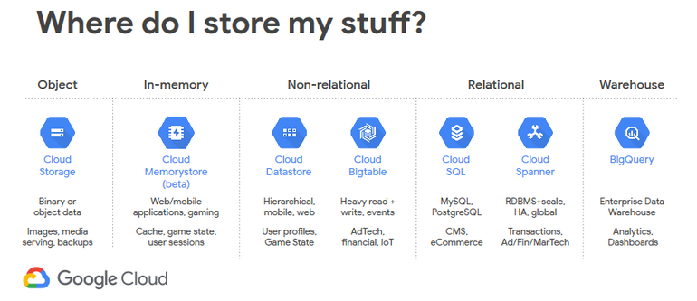http://www.knowstuff.org/2018/04/google-cloud-platform-adds-more-managed-database-services/](http://www.knowstuff.org/2018/04/google-cloud-platform-adds-more-managed-database-services/)

**Cloud SQL**

Google Cloud Database Services comes as part of Google's cloud platform services, and is the last of the big name cloud providers we'll mention here. There are a lot of options for users to choose from, not relational vs non-relational ones. The Cloud SQL option provides managed support for PostgreSQL & MySQL, while the BigTable option provides a petabyte-scale, fully managed NoSQL database service for large analytical and operational workloads.

[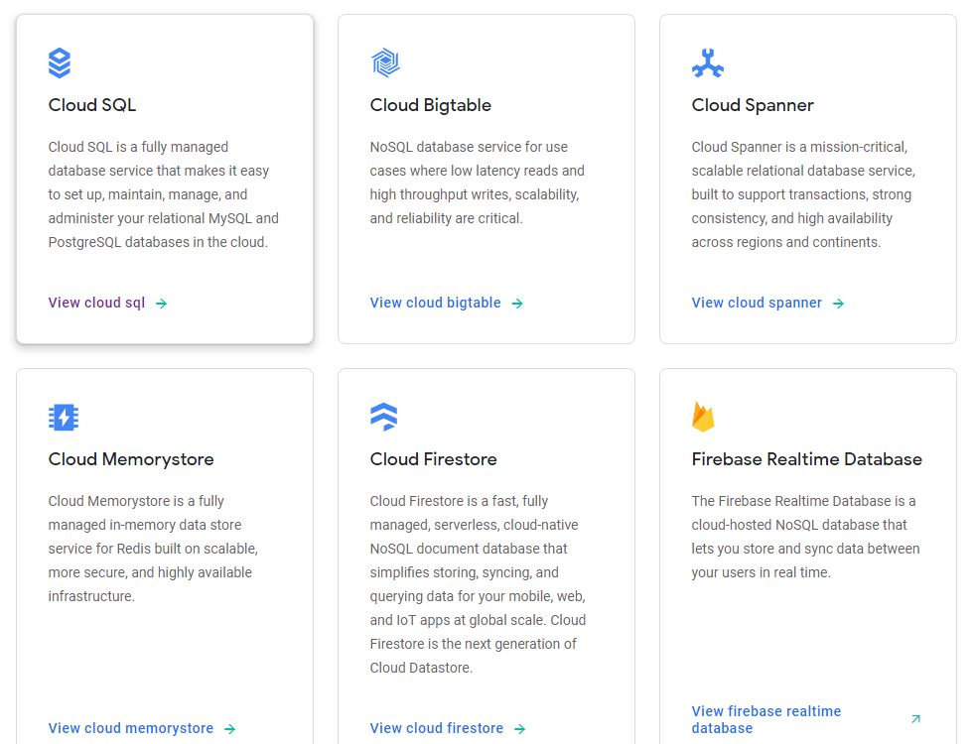https://cloud.google.com/sql/](https://cloud.google.com/sql/)

Google control your database, so you can concentrate on your applications. Cloud SQL is ideal for WordPress sites, e-commerce applications, CRM tools, and any other application that is compatible with MySQL, PostgreSQL, or SQL Server.

Cloud SQL is simple to use. It does not need any software installation. It automates all your backups, replication, patches, and updates.

Cloud SQL delivers high performance and scalability with up to 10 TB of storage capacity.

Simply configure replication and backups to protect your data. The database is highly available, and automatically encrypted.

**Step by step setting up cloud SQL:**

1. Create SQL instance with Google Cloud

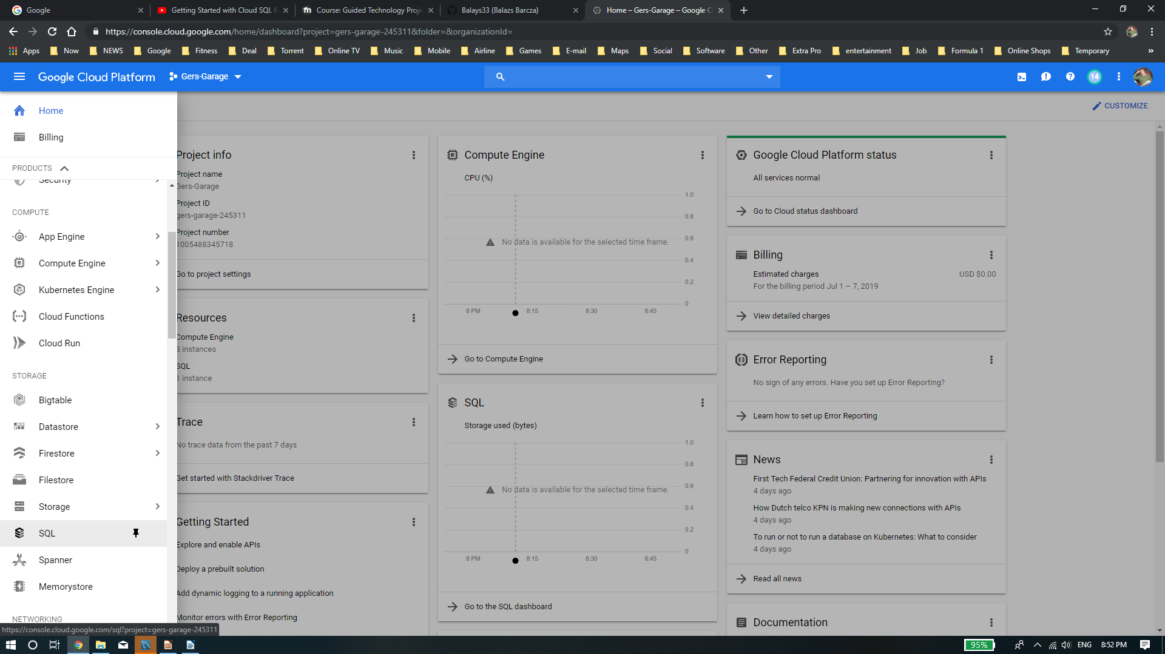Google Cloud navigation bar SQL icon

The google give to use to choose different applications, We can create virtual machines or storage etc. This interface is easy to use and clear design. I like because I get lager working place and If I want to use other service I can find the navigation bar always. The platform easy to set up and personal.

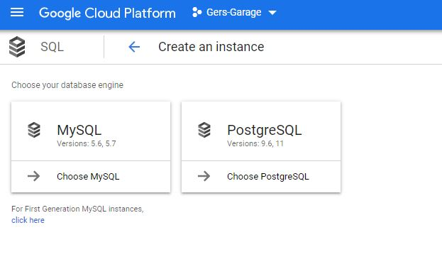We can create MySQL instance or PostgreSQL instance. In my project I will use MySQL because I have experience and I have created my database with MySQL workbench.

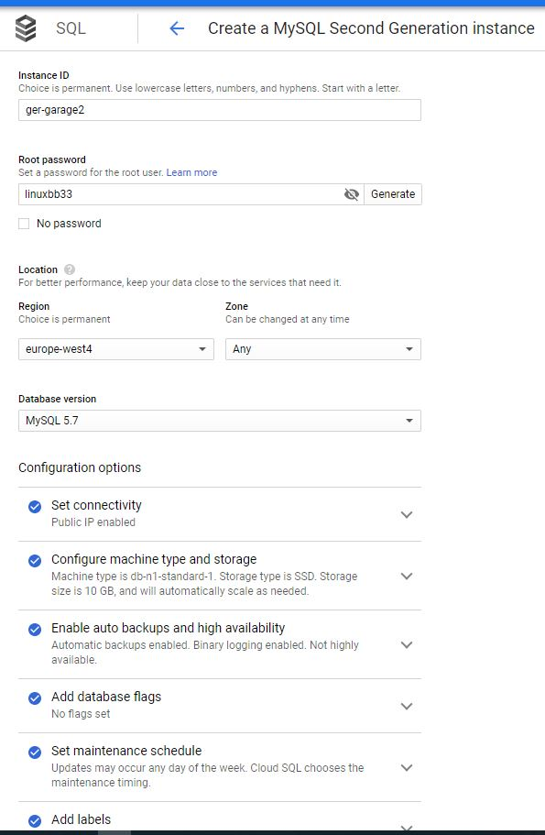We can setup basic parameters with this panel. We can give name of the instance. We can setup password, and the location of the SQL database. We should choose the location but We should leave out the zone any and the Google Cloud will choose the best fit to the project. We can setup the connections (private and public IP).

We can create size of the storage and configurations of the machine. (bigger size better but price is higher) The storage automaticity increase.

Other impotent We can set up when will want to make backup and Failover replica.

High availability

Recommended for all production instances to improve fault tolerance. Failover replica is hosted in a different zone from the master and is billed as a separate instance. [Learn more](https://cloud.google.com/sql/docs/mysql/high-availability?hl=en_US)

Create failover replica

Enter an ID for your failover replica. ID is permanent. Use lowercase letters, numbers and hyphens. Start with a letter.

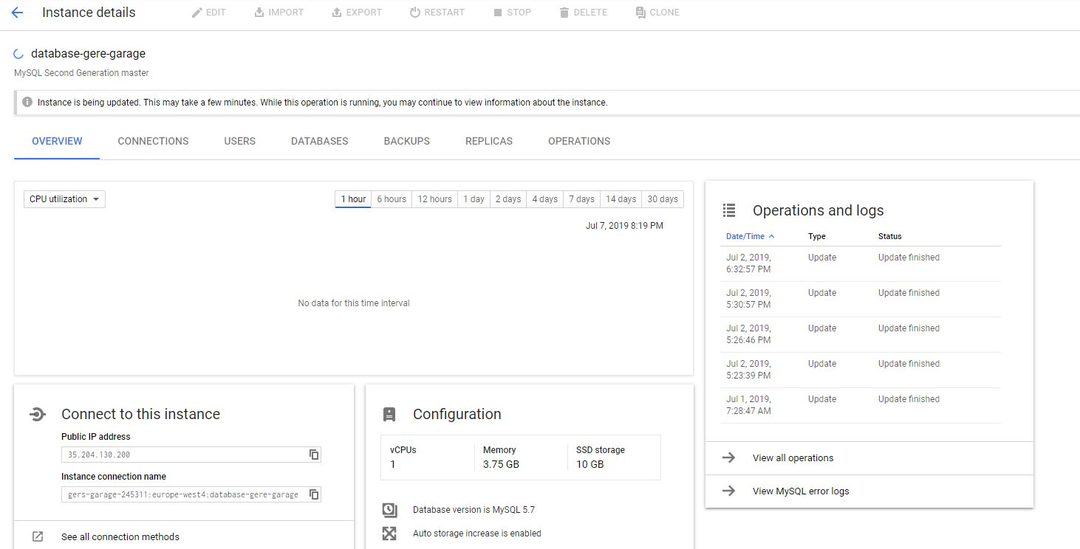This page gives information about the instance details. We can start or stop the instance. We can connecting to the Google shell. There is many ways to connect to the instance. Within GCP, for example, We could use App Engine, Computer Engine or Container Engine. We can connect anywhere by authorizing IP addresses or using Cloud SQL proxy. Google shell provides command line access from the browser.

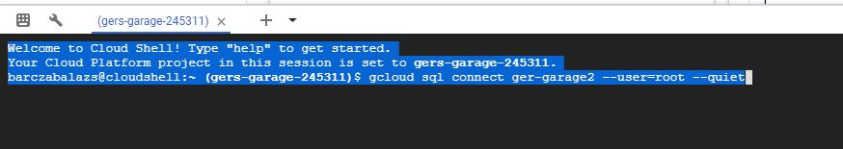 This is the command shell.

“

Welcome to Cloud Shell! Type "help" to get started.Your Cloud Platform project in this session is set to **gers-garage-245311**.barczabalazs@cloudshell:**~ (gers-garage-245311)**$ gcloud sql connect ger-garage2 --user=root --quiet^C   
“

gcloud sql connect ger-garage2 --user=root --quiet



create tabel in GCP shell.



Insert data in to the Database

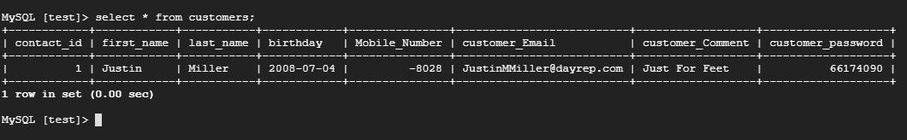

select * from customers;

# System Analysis and Design:

*The overall aim of this chapter is to answer the questions – exactly what is the application*

*supposed to do? It can include the following, where relevant:*

*- Functional Requirements*

*o Detailed description of the functionality of the proposed system. This*

*should be comprehensive and exact, break up the application into*

*subsystems.*

*o Diagrams – use Case diagrams, Wire frames, with text descriptions*

*- Data Requirements*

*o An overview of the entities and data in the system, and what data needs to*

*be stored*

*o Diagrams – an Entity-Relationship Diagram*

*- User Interface Design*

*o This should contain an argument as to how this suggested interface*

*supports each of the use cases specified in the analysis*

*o Diagrams – Screen designs, either pen-and-paper or computer drawn of*

*how the user interface will appear*

*- Functional Design*

*o Functional design should model both the structure of each software*

*component in the systems, and also how they interact with each other.*

*o Diagrams – detailed class diagram and an Interaction Diagram to show*

*the interaction between objects in the system*

*- Data Design*

*o Whether to be implemented as a database or some other central data*

*repository, a detailed design of the data storage components should be*

*presented*

*o Diagrams – Normalised database tables*

## Part 1: Functional Requirements

1. Using virtualization software, **install** 2 virtual machines.

Use *Server 2012 R2 (GUI). ) or Server 2008R2 (GUI)* (Both Server OS not Client OS)

*One VM will act as the Server and the other VM will act as the Client. [Client will also be Web Server]*

## Part 2: User Interface Design

11. This should contain an argument as to how this suggested interface

supports each of the use cases specified in the analysis

o Diagrams – Screen designs, either pen-and-paper or computer drawn of

how the user interface will appear

## Part 3: Functional & Data Design

17. Functional design should model both the structure of each software

component in the systems, and also how they interact with each other.

o Diagrams – detailed class diagram and an Interaction Diagram to show

the interaction between objects in the system

Whether to be implemented as a database or some other central data

repository, a detailed design of the data storage components should be

presented

o Diagrams – Normalised database tables

# Implementation of the system:

*This chapter should detail how the learner implemented a working system based on their*

*design. This should include the technologies used (languages, APIs, frameworks etc.) and*

*how the system was implemented, based on the user and functional requirements*

*identified during the analysis and design phase. This chapter should address any potential*

*problems that could arise in the system and suggested or implemented solutions.*

*Possible areas for discussion in this chapter are:*

*o Architecture considerations - e.g. are there specific functional*

*requirements that will influence the software architecture*

*implementation.*

*o Technologies used - operating systems, databases, computer*

*languages, frameworks, API's etc.*

*o Implementation of the system - main body of work for the chapter. This*

*will discuss precisely how the system was developed, based on the*

*analysis and design considerations.*

*o Problems encountered - any issues that may have arisen during the*

*implementation phase, e.g. the project's cross-platform compatibility*

*between different operating systems.*

## Part 1: Software Architecture Implementation

*Setting up Google Cloud Platform*

*My website will be on the cloud so I have chosen GCP (Google Cloud Platform)*

*Google Cloud Platform, offered by Google, is a suite of cloud computing services that runs on the same infrastructure that Google uses internally for its end-user products, such as Google Search and YouTube.*

Alongside a set of management tools, it provides a series of modular cloud services including computing, data storage, data analytics and machine learning. Google Cloud Platform provides infrastructure as a service, platform as a service, and serverless computing environments.

Why we should transform a business with Google Cloud.

Modernize workloads on Google’s global, secure, and reliable infrastructure.

Develop and run applications using open source and other software without operations staff.

Get insights from data with a full suite of analytics and ML tools.

### **Reduce risk with world-class security**

Your most challenging security scenarios are protected by the same secure-by-design infrastructure, global network, and built-in safeguards that Google uses.

### **Flexible hybrid and multi-cloud options**

Our managed, cloud-native solution means you can write an application once, then run it on-premises, on GCP, or on other clouds with no change in infrastructure

### **Power innovations with AI and ML**

Our easy-to-use artificial intelligence and machine learning capabilities are embedded in our core solutions, making them accessible and easily deployed.

Step by step Setting up a WordPress site on Google Cloud.

Step 1:

I have created a project

Step 2:

Marketplace I have created a virtula machine

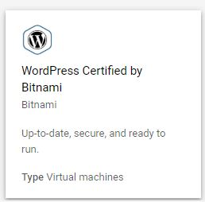

Step 3:

I have to give my WordPress site a name and set up a (0.6GB) micro instance in the Europe West Zone .

Small instance is cheaper.

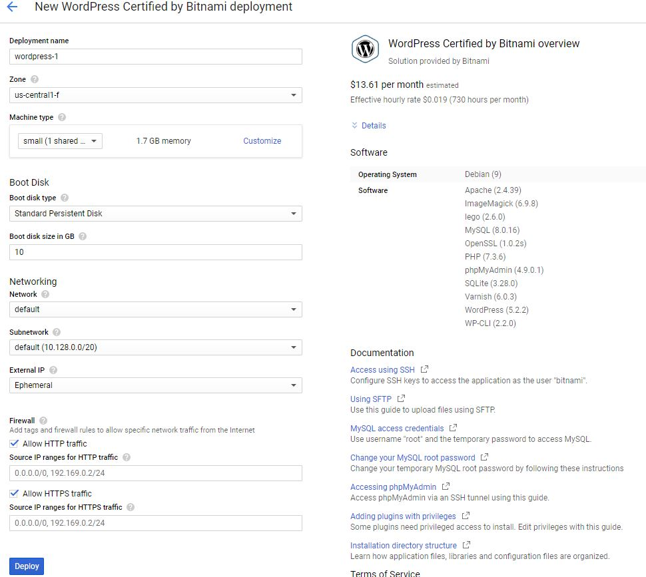

Step 4:

Once to site is complete I can log-in using the username and password given. Note This is the new site has an external IP address

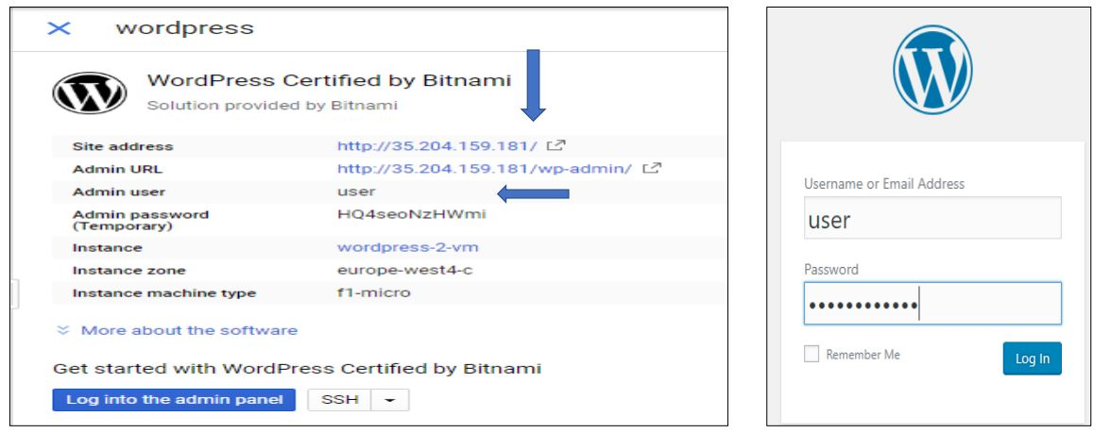

Create easy website.

## Part 2: System Analysis and Design Reflections

11.This will discuss precisely how the system was developed, based on the analysis and design considerations.

## Part 3: Problems confronted

17.Problems encountered - any issues that may have arisen during the implementation phase, e.g. the project's cross-platform compatibility between different operating systems.

# Testing and Evaluation:

*Details of the learner’s test plans, test results, user evaluations and discussion of these*

*results in detail and in summary.*

*Possible entries in this chapter might include:*

*- Functional correctness*

*o Set of tasks system should be able to perform – part of requirements*

*specification of system and include a focus on efficiency*

*o Set of inputs and correct outputs*

*o Set of ‘test scripts’*

*- Objective of test / statement of which part of systems is being*

*tested*

*- Input data/situation*

*- Correct output data / state / behaviour*

*- Need to show actual results of test – screen shots*

*- Evaluation - if actual matches correct then working*

*- Usability*

*o List of usability requirements*

*- set of tasks user should be able to perform*

*- Have a set of tasks for each type of user*

*- System Response times*

*- Time for user to complete a task*

*- Aesthetic*

*- Acceptable navigation of site and layout*

*o Set of ‘test scripts’*

*- Instructions for user*

*- Observation / measure time / evaluate success of task*

*- Analyse results to come up with usability result*

*o Can also measure qualitative usability aspects with questionnaires /*

*structured interviews etc.*

*- Commercialisation / marketing*

*o Requirements – registration on web search engines, direct marketing –*

*discuss real commercialisation aspects of project*

*o Evaluation – have set of key words / phrases for targeted websites*

## Part 1: Functional Requirements

1. *Set of tasks system should be able to perform – part of requirements*

*specification of system and include a focus on efficiency*

*o Set of inputs and correct outputs*

*o Set of ‘test scripts’*

*- Objective of test / statement of which part of systems is being*

*tested*

*- Input data/situation*

*- Correct output data / state / behaviour*

*- Need to show actual results of test – screen shots*

*- Evaluation - if actual matches correct then working*

*- Usability*

## Part 2: Instructions for user

11. **CompuTech has two departments. Using Active Directory Users and Computers**

**(ADUC), create 2 departments** (Organizational Units) called Accounting-Dublin and Sales-Dublin.

Inside the **Accounting-Dublin** OU and in the **Sales-Dublin** OU create user accounts, and network groups as specified below:

12. Inside the **Accounting-Dublin** OU create a Global Security group called **Accounting** and then create the 5 **Accounting** users accounts shown below, using the names supplied.

## Part 3: Commercialisation / Marketing

17. Requirements – registration on web search engines, direct marketing –discuss real commercialisation aspects of project Evaluation – have set of key words / phrases for targeted websites

# Conclusions:

*The Individual needs to review the entire project against their problem context, aims and*

*objectives, and evaluate project success and results. This may also include a section for*

*suggestions for further work.*

*Appendix A: Code Listings*

*This should be a link to a cloud resource (such as GitHub) where the project code is*

*maintained. Students should have only included selected code fragments or algorithm*

*summaries in the main chapters, otherwise the project report can become a monotonous*

*technical manual rather than a story of what they did and why they did it.*

## Part 1: Evaluate the success and results of the project

1. Using virtualization software, **install** 2 virtual machines.

Use *Server 2012 R2 (GUI). ) or Server 2008R2 (GUI)* (Both Server OS not Client OS)

*One VM will act as the Server and the other VM will act as the Client. [Client will also be Web Server]*

## Part 2: Suggestions for further work

11. **CompuTech has two departments. Using Active Directory Users and Computers**

**(ADUC), create 2 departments** (Organizational Units) called Accounting-Dublin and Sales-Dublin.

Inside the **Accounting-Dublin** OU and in the **Sales-Dublin** OU create user accounts, and network groups as specified below:

12. Inside the **Accounting-Dublin** OU create a Global Security group called **Accounting** and then create the 5 **Accounting** users accounts shown below, using the names supplied.

# Code Listings:

This should be a link to a cloud resource (such as GitHub) where the project code is

maintained. Students should have only included selected code fragments or algorithm

summaries in the main chapters, otherwise the project report can become a monotonous

technical manual rather than a story of what they did and why they did it.

## Part 1: #####

## Part 2: ####

11. **CompuTech has two departments. Using Active Directory Users and Computers**

## Part 3: ####

# Appendix B: (other technical or data appendices as required):

If you have additional technical data to showcase it should be included in this appendix,

you can also use this appendix to present the raw data of empirical research carried out

(questionnaires, interviews etc.)

## Part 1: : Project Planning

1. U

## Part 2: Reflective Learning Journal

11. **C**

# List of References:

All citations used within the report should include their full reference using the Harvard

referencing style. A reference list should be included in this section of the report.

17. U